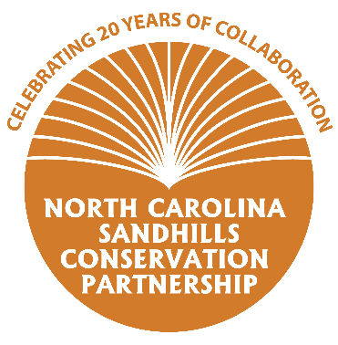
Questionnaire for the 20-Year Anniversary of the
NC Sandhills Conservation Partnership
Thank you for taking the time to fill out this short questionnaire! The information you provide will be used to create outreach material including handouts and social media content to promote the anniversary of the Partnership.

- What kind of work does your organization do to conserve natural resources in the Sandhills? The North Carolina Forest Service (NCFS) assists private landowners with the management of their land. We provide forest management plans, assist in locating contractors to get work done, and conduct prescribed burns for landowners.
- What benefits does your organization receive from being involved with the Sandhills Conservation Partnership? Please feel free provide a specific example of how collaboration afforded through the Partnership has helped you achieve a specific conservation goal. By being part of the SCP, the NCFS learns more about programs other agencies have available to landowners. We can then present this information to landowner we are working with, when it helps to meet their objectives.
- What are some of your major accomplishments in the last 20 years? For example, how many acres of land have you helped protect/restore/manage? How many landowners have you provided technical guidance to?
Over the past 20 years of assisting private landowners, in the sandhills, the NCFS has accomplished the following: prepared over 10,500 forest management plans covering close to 500,000 acres, assisted with over 6,200 forest establishment projects covering greater than 205,000 acres and have burned or assisted landowners with 1,500 burns on greater than 140,000 acres.
- How can the general public get more information and/or become involved with your organization? For example, hiking, hunting, landowner technical assistance, volunteer days, etc. Landowners can contact their local NCFS county office to obtain forest management assistance. The NCFS webpage has the contact information for each county office: https://www.ncforestservice.gov/contacts/contacts_main.htm

- What else would you like the general public to know about your organization? Do you have any fun facts or stories to share?

