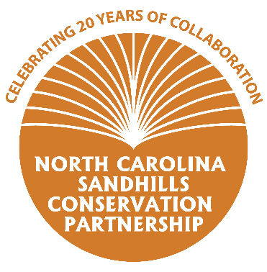
Questionnaire for the 20-Year Anniversary of the
NC Sandhills Conservation Partnership
Thank you for taking the time to fill out this short questionnaire! The information you provide will be used to create outreach material including handouts and social media content to promote the anniversary of the Partnership.

- What kind of work does your organization do to conserve natural resources in the Sandhills? The Wildlife Resources Commission manages the ~65,000 acre Sandhills Game Land as well as Nicholson Creek GL to benefit game species as well as the entire suite of non-game species that require high quality Longleaf Pine and other associated habitats.

- What benefits does your organization receive from being involved with the Sandhills Conservation Partnership? Please feel free provide a specific example of how collaboration afforded through the Partnership has helped you achieve a specific conservation goal. The WRC has added over 6,000 acres to the Game Land program in the Sandhills and none of it would have been possible without involvement of the NCSCP.

- What are some of your major accomplishments in the last 20 years? For example, how many acres of land have you helped protect/restore/manage? How many landowners have you provided technical guidance to? WRC has protected over 6,000 acres through the partnership. We have also increased prescribed burn capacity and added over 50 new RCW clusters to the Sandhills Game Land.

- How can the general public get more information and/or become involved with your organization? For example, hiking, hunting, landowner technical assistance, volunteer days, etc. The Sandhills Game Land is open for public access 365 days per year and offers hunting, fishing and other outdoor recreational opportunities during appropriate seasons. More info at www.NCWildlife.org

- What else would you like the general public to know about your organization? Do you have any fun facts or stories to share?

