The 2022 Carolina’s Largest Venus Flytrap Contest
Sponsored by Southern Conservation Partners, Inc.
- Where do the largest Venus Flytraps grow?
- How large do the traps on Venus Flytraps grow in the wild?
- Where are you finding exceptionally large Venus Flytraps?
- Why do you think the traps are so large? Regular burning, soil, topography?

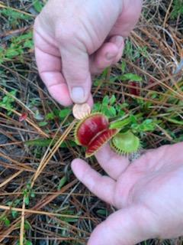

Document the size of the trap using a US penny for scale (see above). Send a photo, general location information on entry form at venusflytrapchampions.org.

Contest entries will be accepted until July 1, 2022.

Note: Precise locations will not be identified or published, with your permission a new population location will be shared with the NC & SC Natural Heritage Programs.

