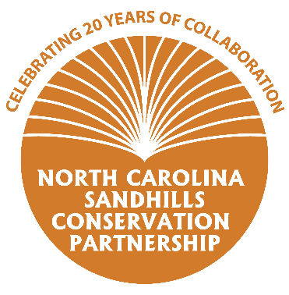
Questionnaire for the 20-Year Anniversary of the
NC Sandhills Conservation Partnership
Thank you for taking the time to fill out this short questionnaire! The information you provide will be used to create outreach material including handouts and social media content to promote the anniversary of the Partnership.

- What kind of work does your organization do to conserve natural resources in the Sandhills?
In the NC Sandhills, The Nature Conservancy (TNC) protects land and restores habitat. TNC protects land through purchase or conservation easement and many of the properties that TNC purchases are transferred to State Parks or NC Wildlife Resources Commission and are available for public use. TNC restores longleaf pine forests and other habitats on the ~6000 acres owned by TNC and we also assist partners with habitat management. TNC uses a variety of management techniques, with a special emphasis on controlled burning. In addition, TNC is involved in research, surveys, conservation planning, and supporting partnerships to help make conservation work more effective.

- What benefits does your organization receive from being involved with the Sandhills Conservation Partnership? Please feel free provide a specific example of how collaboration afforded through the Partnership has helped you achieve a specific conservation goal.
Participation in the Sandhills Conservation Partnership helps TNC to be aware of what other partners are working on and helps us to avoid missing opportunities or duplication of effort. We stay informed on issues such as the population status of red-cockaded woodpeckers or the latest research on gopher frogs, Bachman’s sparrows, or southern hognose snakes, to name a few. TNC utilizes the conservation priority maps (the “Reserve Design”) produced by the Partnership to prioritize land conservation and restoration efforts. The Partnership has been particularly helpful to TNC in implementing our Cooperative Agreement with the US Army to protect land and habitat surrounding Fort Bragg and Camp Mackall.

- What are some of your major accomplishments in the last 20 years? For example, how many acres of land have you helped protect/restore/manage? How many landowners have you provided technical guidance to?

In the past 20 years, TNC has protected 21,827 acres through fee simple purchase or conservation easement. TNC has planted longleaf pine and native grasses on over 2,000 acres and burns about 1,800 acres per year on TNC-owned lands while helping partners to burn up to 20,000 acres per year. Our science has helped to set priorities for conservation and restoration work and has helped to track progress towards conservation goals.

- How can the general public get more information and/or become involved with your organization? For example, hiking, hunting, landowner technical assistance, volunteer days, etc.
TNC’s Calloway Preserve, also known as Rockfish Creek Game Land, in Hoke County is open to the public for hiking, horseback riding, and hiking. The public can become a member of TNC to support our work and to get access to member hikes, field tours, newsletters, and other information. TNC uses volunteers to help with activities such as wiregrass seed collecting and tree planting, and on a limited basis also controlled burning and wildlife and habitat surveys. TNC staff are available to consult with landowners about options for conserving and managing their land. More information is available at www.nature.org or by calling 910-246-0300.

- What else would you like the general public to know about your organization? Do you have any fun facts or stories to share?
- The Nature Conservancy helped to form the first-in-the-nation Army Compatible Use Buffer program by working with Fort Bragg and other stakeholders to create a program that helps protect military training from incompatible development on the border of Fort Bragg, while also recovering endangered species populations.
- TNC has 5 full-time and 10 seasonal staff in the NC Sandhills.
- TNC is a leader in planning for climate resilience in longleaf pine and other ecosystems.
- Red-cockaded woodpeckers increased from 4 to 11 breeding groups on Calloway with 16 years of TNC stewardship.
- The TNC Sandhills field office also protects and restores Carolina Bays, unique and globally rare wetlands found just east of the Sandhills

